|  |
| --- |
| NEELADHRI CERAMICS |
| Changes required in the website and Content 2 |
| Aniruddha Setty |

About Us

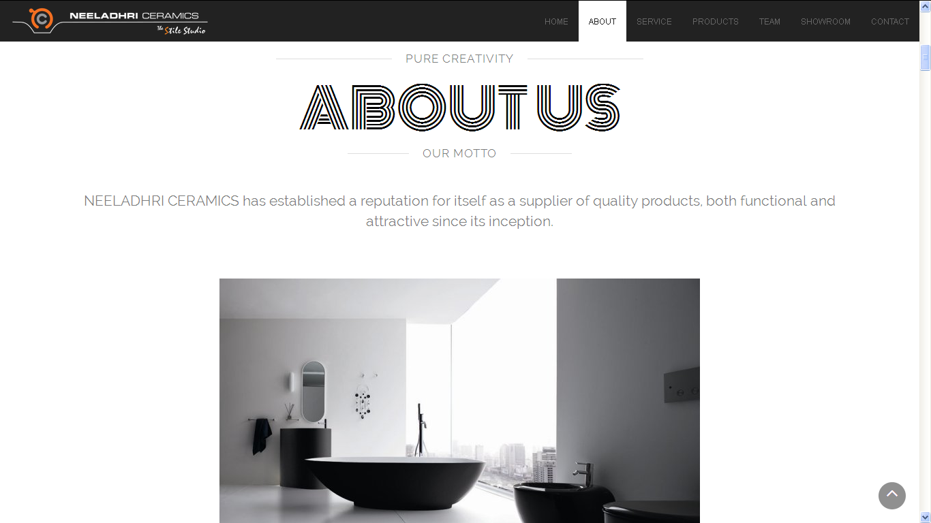

* It says OUR MOTTO, but our motto is “Excellence through Hi-Quality Products and Services so as to provide you the Best Value for Money.”
* Therefore either change “OUR MOTTO” or change the wordings given below to MOTTO.
* If you feel that this change is not required you can just leave it like that.

About Us 2

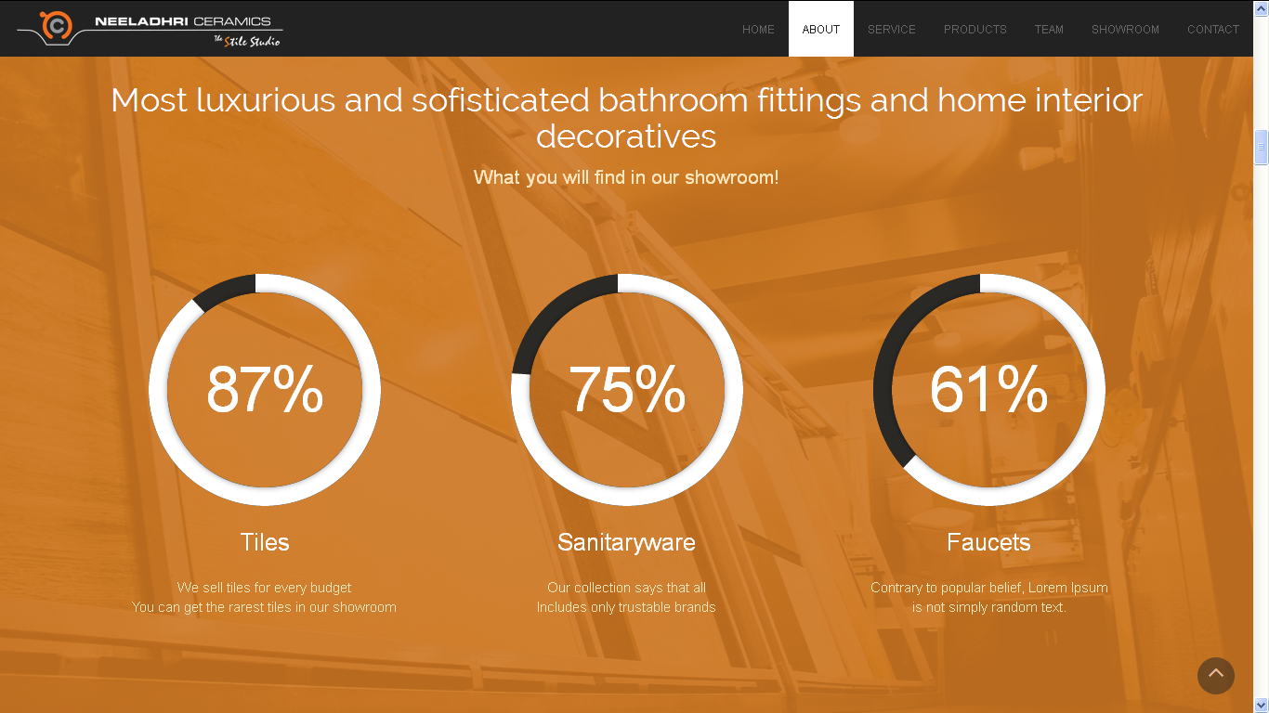

* Please remove the word MOST in the beginning.

Services

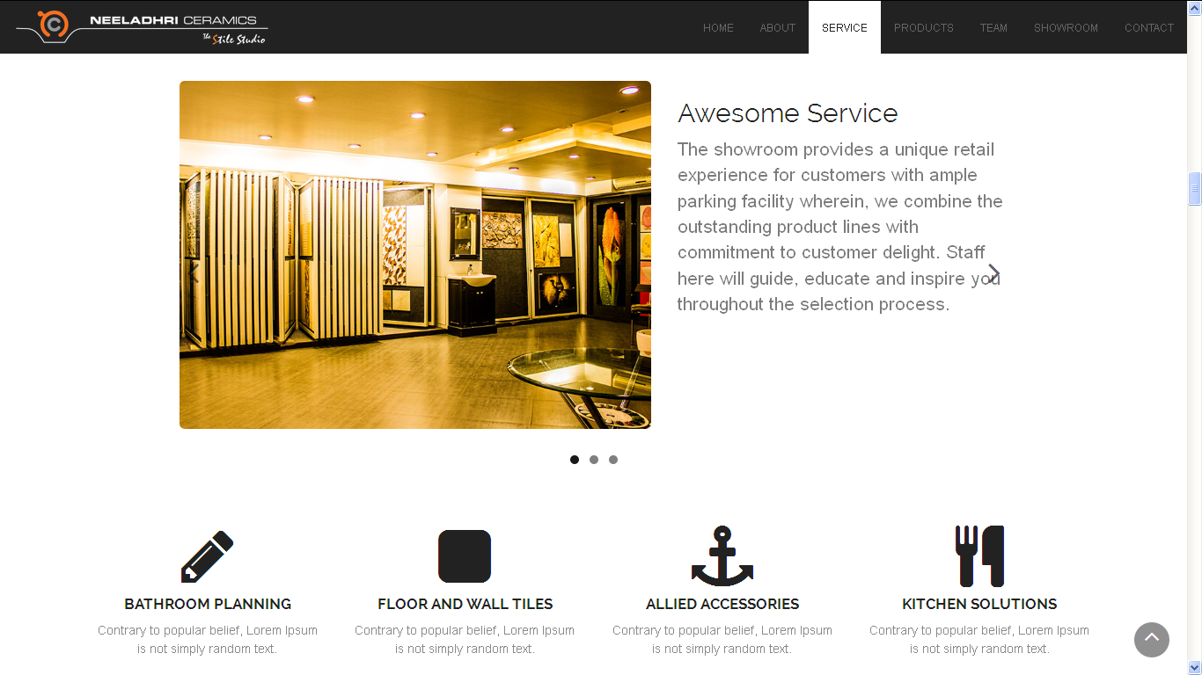

* Use a different word rather than AWESOME.
* Contrary to popular belief, Lorem Ipsum is not simply random text. Instead of having this 4 times just mention the same in one single line covering all four.
* Kitchen Solutions should come 3rd and then Allied Accessories in the last
* 3 images contrast needs to be reduced.

Services 2

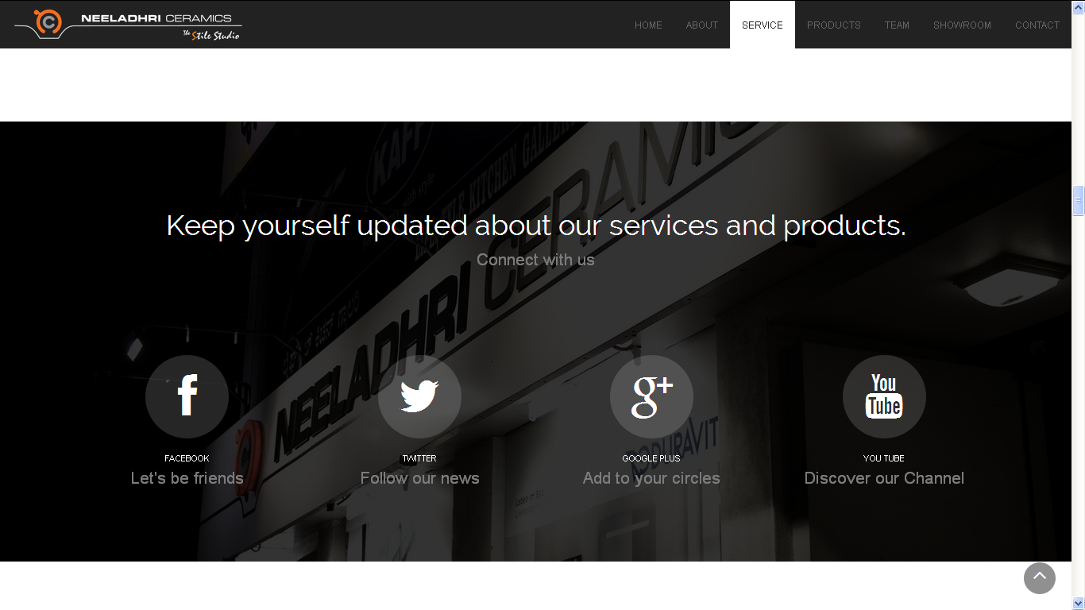

* Facebook link : <https://www.facebook.com/ceramics.neeladhri>
* Twitter link: <https://twitter.com/neeladhricera>
* Google + link: <https://plus.google.com/113319486940172443614/about?gl=in&hl=en>
  + This is the page, but admin controls for this are not with me, so let me know how to gain this control as well.
* YouTube Link: currently the link is not available, if I get the admin control of G+ account from that id itself I would create a YouTube account.

.

Our Team

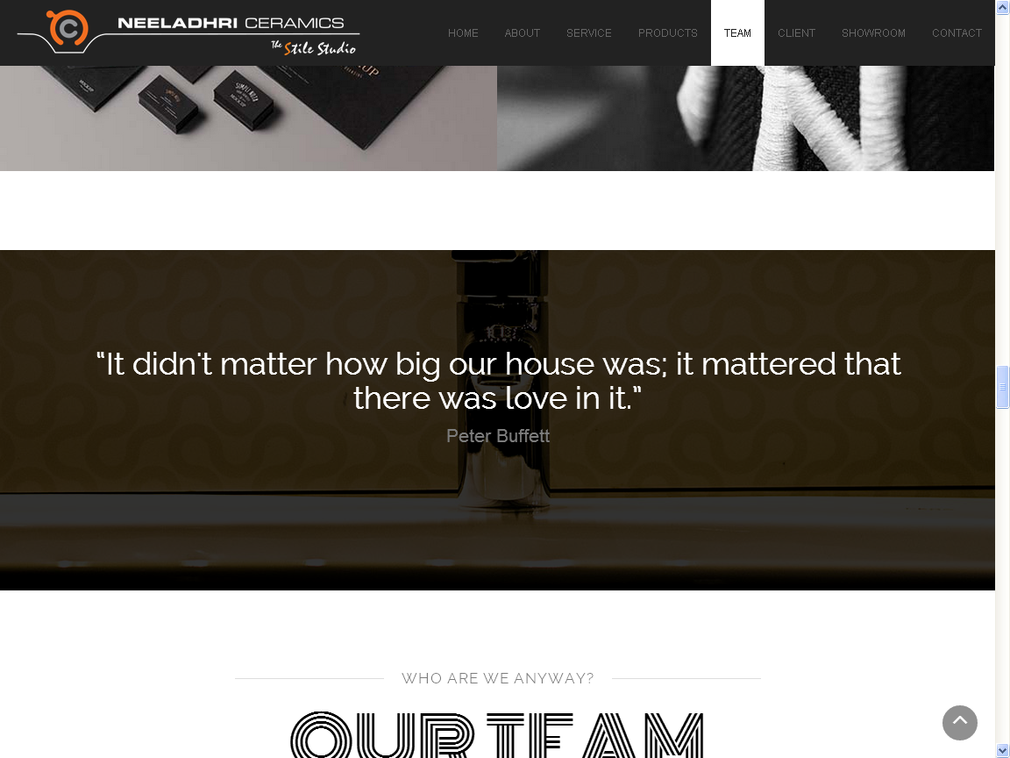

* This page seems to be just fine.
* Background needs to be little brighter
* Name needs to be more legible

Our Team 2

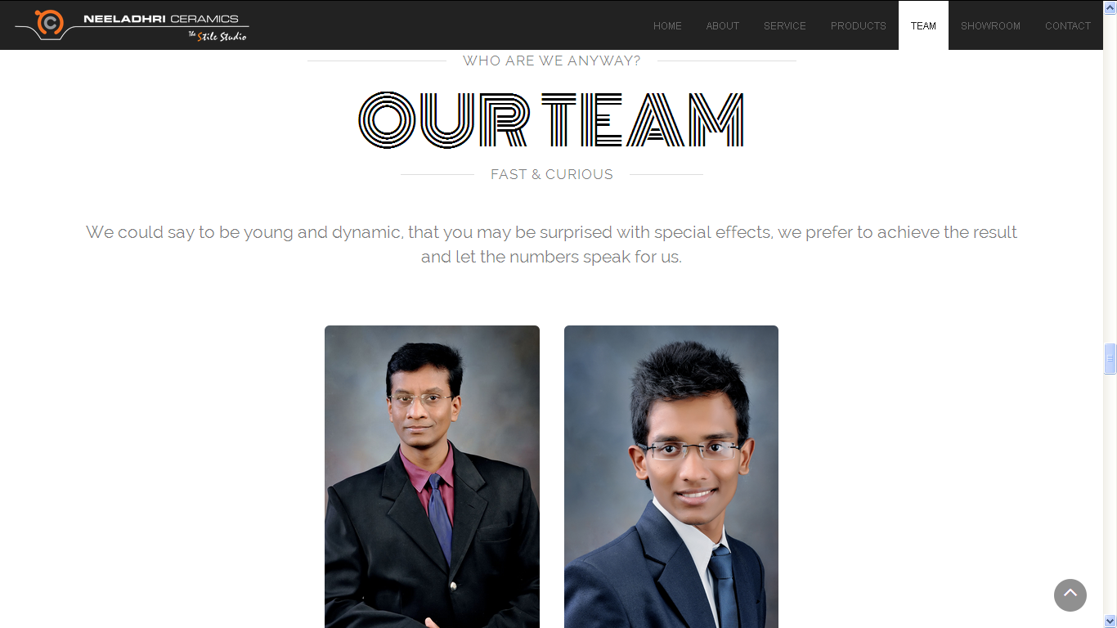

* Mr. Badrinath C R (Mr. Badrinath doubles up as the founder and managing partner of the firm, when it comes to being prolific, it doesn't get much bigger than him, he can make magic out of an empty window sill, because that’s how he sees life: in magical, beautiful, ever-transforming frames.)
  + Founder and Managing Partner (the letter P needs to be capital)
  + Facebook: <https://www.facebook.com/neeladhribadrinath>
  + Google +: <https://plus.google.com/u/0/107478048090277729269/posts>
  + He is not having an YouTube account.
* Mr. Aniruddha C B (This thin, tall, weirdly innovative, oddly magical boy who is passionate about what he does, pours heart and soul into everything he decides to do. There is no midway for him- not in cooking a six course meal, not in life, certainly not in his work.)
* Instead of branding and marketing head change it to BUSINESS DEVELOPMENT MANAGER
  + Facebook: [www.facebook.com/aniruddha.setty](http://www.facebook.com/aniruddha.setty)
  + Google +: [google.com/+AniruddhaSetty](https://www.google.com/+AniruddhaSetty)
  + YouTube: <https://www.youtube.com/user/aniruddhasetty93>

Client

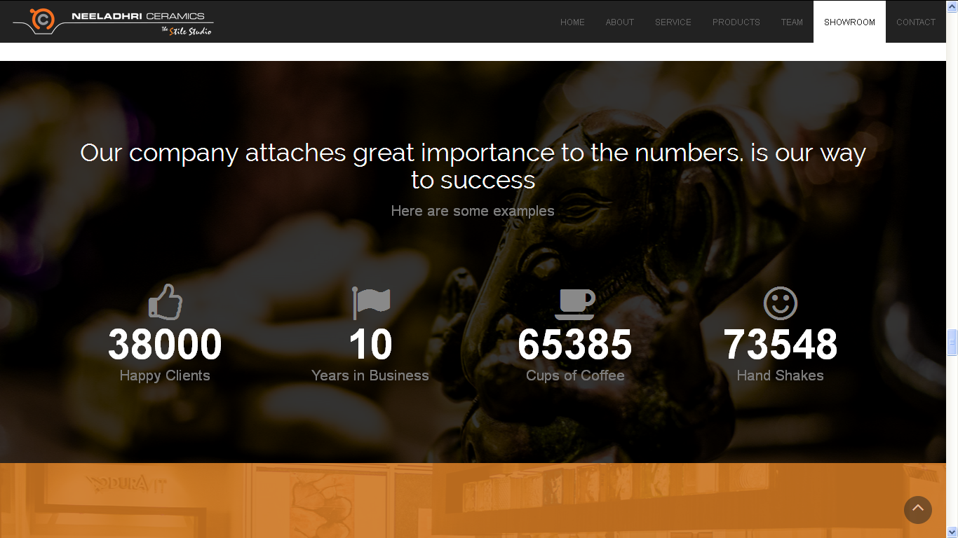

* Happy Clients 38000 +
* Years in Business 10
* Cups of Coffee 65385 +
* Handshakes 73548+
* Handshakes symbol needs to be changed to the handshake symbol
* Mention the symbol (+), in case you feel it looks more realistic

Clients 2

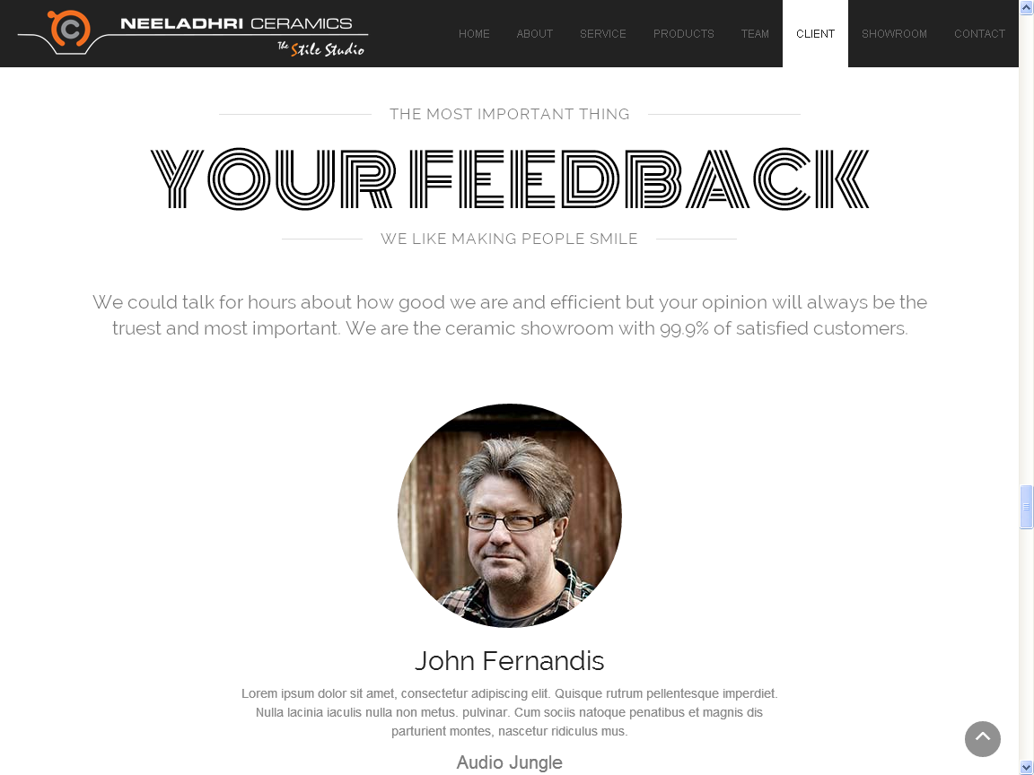

* This feedback page is missing!!!!!!!!!!!!!!

Our Showroom

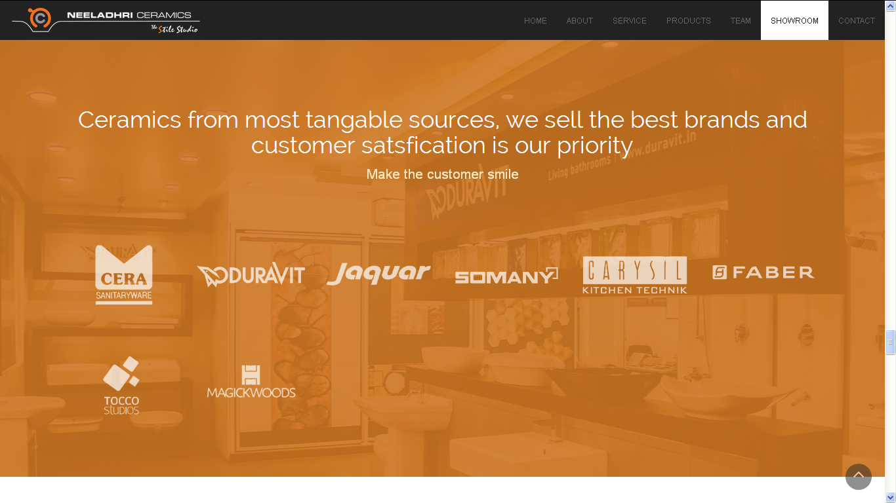

* The brands that we deal with are:
  + Cera (Old Logo needs to be changed to new logo)
  + Duravit (Perfect)
  + Jaquar (Perfect)
  + Somany (Perfect)
  + Schablona (Mail was sent by Pappa few weeks ago)
  + Carysil (Perfect)
  + Faber (Perfect)
  + Tocco (Perfect)
  + Magickwood (Perfect)
  + Farriti (Find attachment)
  + Ego Flooring (Find attachment)

Our Showroom 2

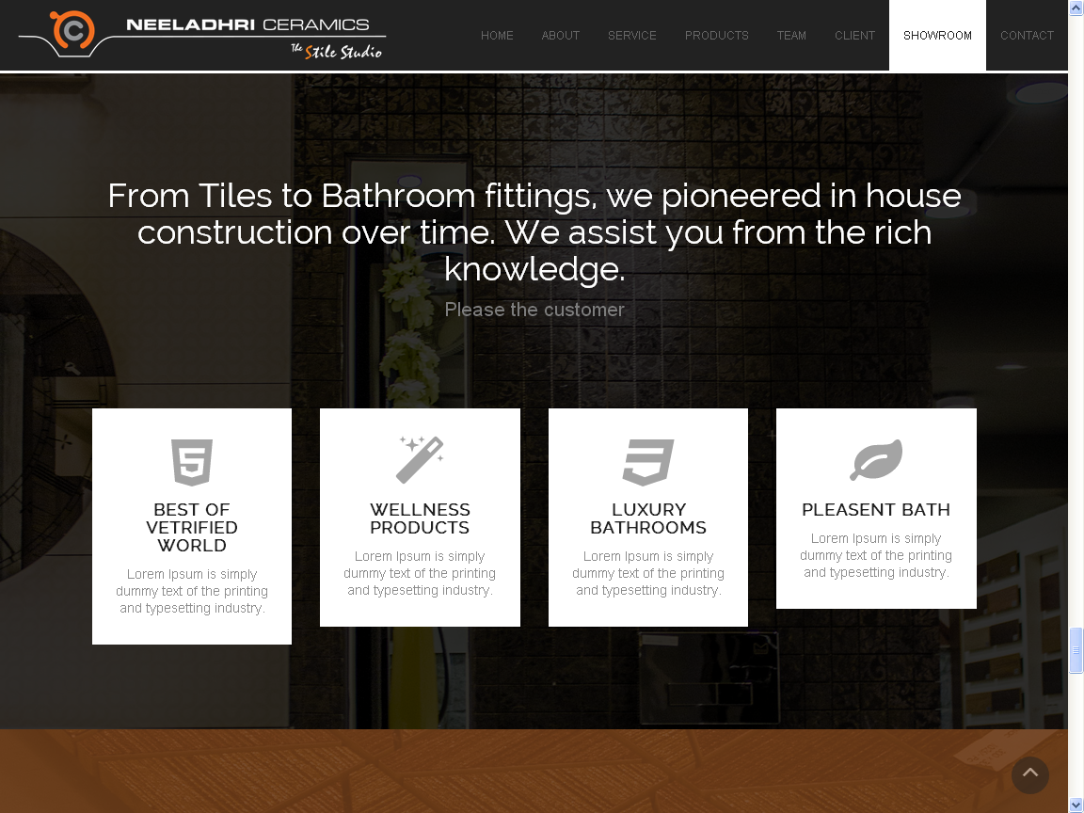

* The state-of-the-art showroom offers you an opportunity to create your very own dream bathroom with a wide range of Sanitary wares, Tiles for wall and floor, Bath Fittings, Whirlpools, Bath Systems, Hobs and Chimneys, Multifunction Systems and Bath Tubs.
* The showroom provides a unique retail experience for customers with ample parking facility wherein, we combine the outstanding product lines with commitment to customer delight. Staff here will guide, educate and inspire you throughout the selection process.
* We offer value for money products to our valuable customers. You can avail our service from well experienced sales personnel at any time regarding our products and services.
* We assure the best package of virtual colours and designs, and it will help you in providing a broad spectrum of integrated solutions for a perfect dream home.
* Please try to convey this message along with the tabs(mentioned in About Us)
* THIS PAGE IS MISSING!!!!
* In this page you can stress on our core competencies indirectly. Please incorporate that

Contact Us

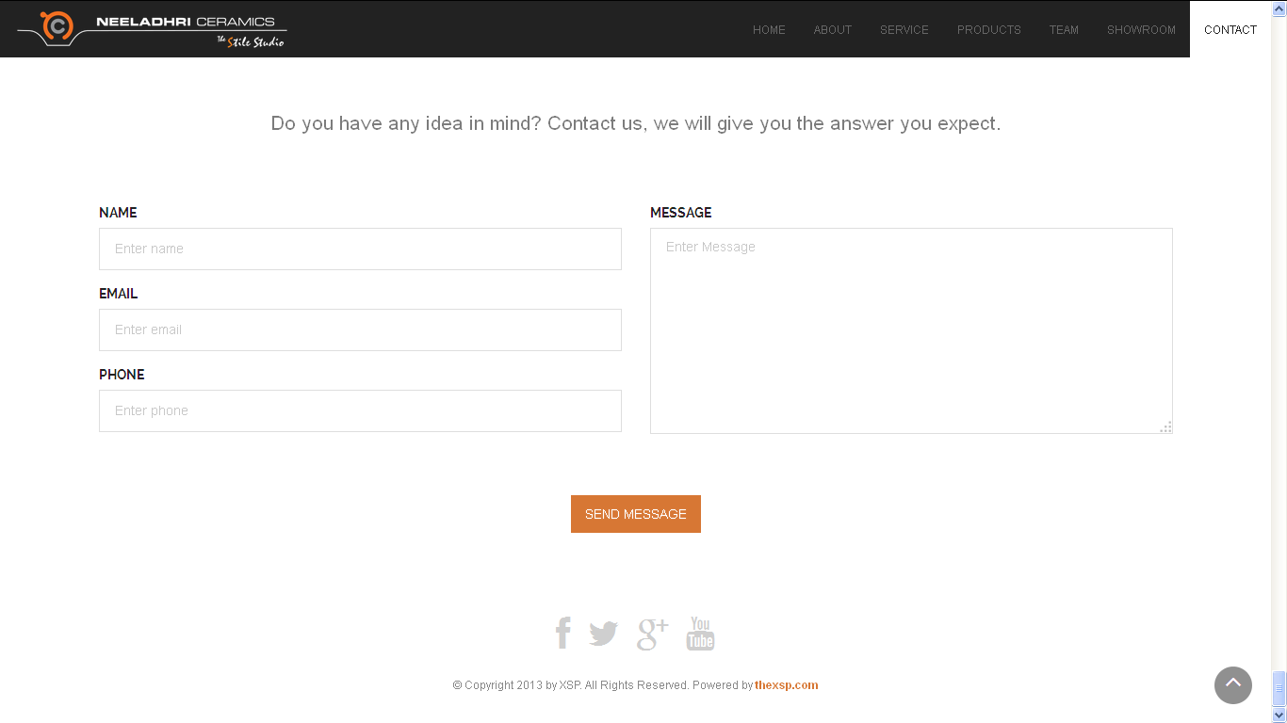

* This part seems to be bland, please make it little more interesting.
* Instead of SEND MESSAGE, change it to request a phone call and make all the 4 blanks compulsory.

Overall Website Changes

* All waiting signs in the webpage should be company logo with rotating animation or something similar to Windows 8 where the logo of the company is still and few dots moving from left to right at the bottom or something quite unique and different animation along with the company logo.
* Kindly send me the images which were captured, along with the image of the company name and logo without back ground in black letters and logo retaining to the same colour.
* Company logo and name seems to be little small on bigger screens, please correct this.
* When the new page for gallery viewing is opened the waiting logo seems to be very pale and not perfect, change that immediately.
* If you find any links to be missing and not provided let me know.